J. angielski – 3, 4 latki
Propozycje zadań

- Piosenka na powitanie

https://www.youtube.com/watch?v=gdeB9kDT6uI

- Utrwalenie nazw kolorów.

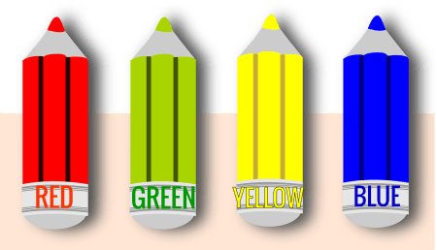

- Piosenka
https://supersimple.com/song/red-yellow-green-blue/
Red, yellow, green, blue.
Red, yellow, green, blue.
Red.
Yellow.
Green.
Blue.
Red, yellow, green, blue.
Red, yellow, green, blue.
Red.
Yellow.
Green.
Blue.
Red is the color of an apple.
Yellow is the color of the sun.
Green is the color of a four leaf clover.
And blue is the color of the sky above.
Red, yellow, green, blue.
Red, yellow, green, blue.
Red.
Yellow.
Green.
Blue.
Red, yellow, green, blue.
Red, yellow, green, blue.
Red.
Yellow
Green
Blue

- Zadanie
